**Obrázková krížovka:**

**Pri práci v chemickom laboratóriu musíme dbať na ..........**

*(odpoveď sa ukrýva v tajničke)*

Názvy laboratórnych pomôcok vpíš do krížovky.

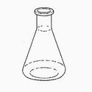 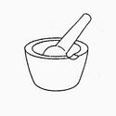 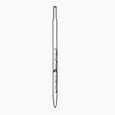

1 2 3

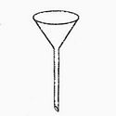 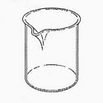 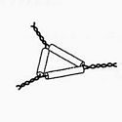

4 5 6

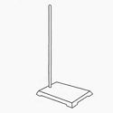 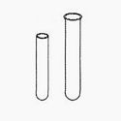 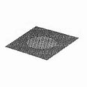

7 8 9

|  |  |  |  |  |  |  |  |  |  |  |  |  |  |
| --- | --- | --- | --- | --- | --- | --- | --- | --- | --- | --- | --- | --- | --- |
|  |  |  |  |  |  |  |  |  |  |  |  |  |  |
|  |  |  |  | **1** |  |  |  |  |  |  |  |  |  |
|  |  | **2** |  |  |  |  |  |  |  |  |  |  |  |
|  |  |  |  |  | **Z** |  |  |  |  |  |  |  |  |
|  |  |  |  | **3** |  |  |  |  |  |  |  |  |  |
|  |  | **4** |  |  |  |  |  |  |  |  |  |  |  |
| **5** |  |  |  |  |  |  |  |  |  |  |  |  |  |
| **6** |  |  |  |  |  |  |  |  |  |  |  |  |  |
|  |  | **7** |  |  |  |  |  |  |  |  |  |  |  |
|  |  |  |  | **8** |  |  |  |  |  |  |  |  |  |
|  | **9** |  |  |  |  |  |  |  |  |  |  |  |  |

**Riešenie obrázkovej krížovky:**

|  |  |  |  |  |  |  |  |  |  |  |  |  |  |
| --- | --- | --- | --- | --- | --- | --- | --- | --- | --- | --- | --- | --- | --- |
|  |  |  |  |  |  |  |  |  |  |  |  |  |  |
|  |  |  |  | **1** | **B** | A | N | K | A |  |  |  |  |
|  |  | **2** | T | R | **E** | C | I | A | M | I | S | K | A |
|  |  |  |  |  | **Z** |  |  |  |  |  |  |  |  |
|  |  |  |  | **3** | **P** | I | P | E | T | A |  |  |  |
|  |  | **4** | L | I | **E** | V | I | K |  |  |  |  |  |
| **5** | K | A | D | I | **Č** | K | A |  |  |  |  |  |  |
| **6** | T | R | I | A | **N** | G | E | L |  |  |  |  |  |
|  |  | **7** | S | T | **O** | J | A | N |  |  |  |  |  |
|  |  |  |  | **8** | **S** | K | Ú | M | A | V | K | A |  |
|  | **9** | S | I | E | **Ť** | K | A |  |  |  |  |  |  |

Zdroje obrázkov:

[www.predmety.skylan.sk](http://www.predmety.skylan.sk)